EPIC - 1

Design and Analysis of ER Diagram

INTRODUCTION:
FinRelief AI is an AI-powered financial advisory system that helps users manage debts, analyze their financial health, predict loan settlements, and generate AI-assisted negotiation strategies. The ER (Entity Relationship) Diagram represents the database structure of the application and shows how different entities are connected.

ER-DIAGRAM:
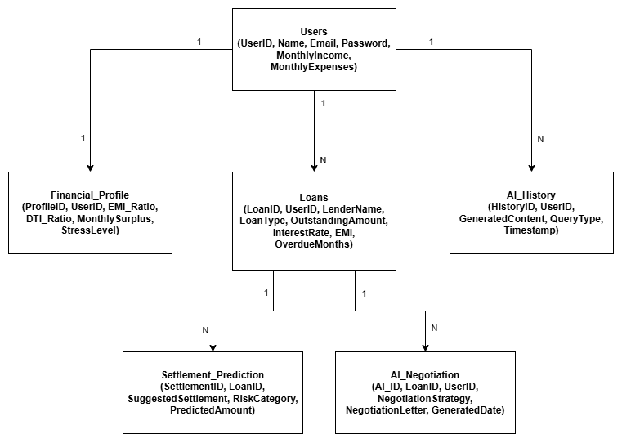

DESCRIPTION: The ER Diagram of FinRelief AI illustrates the relationships between users, financial profiles, loans, AI history, settlement prediction, and AI negotiation. It provides a structured database design that supports AI-powered financial planning, debt management, and personalized recommendations.
USER - Stores user account and financial information.
Attributes:
- UserID
- Name
- Email
- Password
- MonthlyIncome
- MonthlyExpenses

FINANCIAL PROFILE -Stores the financial health of the user.
Attributes:
- ProfileID
- UserID
- EMI_Ratio
- DTI_Ratio
- MonthlySurplus
- StressLevel

LOANS - Stores loan information.
Attributes:
- LoanID
- UserID
- LenderName
- LoanType
- OutstandingAmount
- InterestRate
- EMI
- OverdueMonths
AI-HISTORY - Stores AI-generated content.
Attributes:
- HistoryID
- UserID
- GeneratedContent
- QueryType
- Timestamp

SETTLEMENT PREDICTION - Stores settlement recommendations.
Attributes:
- SettlementID
- LoanID
- SuggestedSettlement
- RiskCategory
- PredictedAmount

AI_NEGOTIATION - Stores AI-generated negotiation letters.
Attributes:
- AI_ID
- LoanID
- UserID
- NegotiationStrategy
- NegotiationLetter
- GeneratedDate

RELATIONSHIPS:
Users → Financial_Profile = One-to-One (1:1)
Users → Loans = One-to-Many (1:N)
Users → AI_History = One-to-Many (1:N)
Loans → Settlement_Prediction = One-to-Many (1:N)
Loans → AI_Negotiation = One-to-Many (1:N)

The relationships among the entities are:
- One User has one Financial Profile (1:1).
- One User can have multiple Loans (1:N).
- One User can have multiple AI History records (1:N).
- One Loan can have multiple Settlement Predictions (1:N).
- One Loan can have multiple AI Negotiation records (1:N).
These relationships help maintain data consistency and reduce redundancy in the database.

CONCLUSION:
The ER Diagram provides a clear database structure for FinRelief AI. It establishes relationships between users, loans, financial profiles, AI-generated recommendations, and negotiation records. This design ensures organized data storage, reduces redundancy, and supports efficient AI-driven financial analysis.

***

